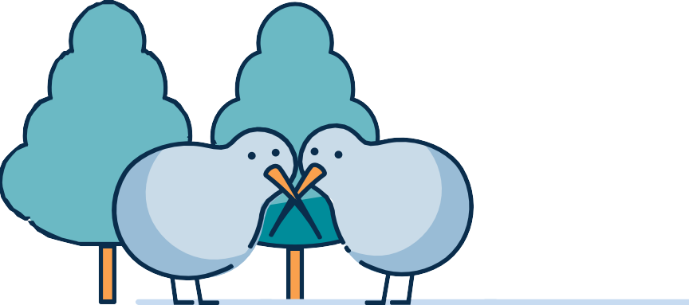

Financial support for Cyclone Gabrielle
Note: at the bottom of each page there are logos for the Ministry of Social Development Te Manatū Whakahiato Ora (left) and Work and Income Te Hiranga Tangata (right).

Introduction
We may be able to provide you with support and assistance if you’ve been affected by Cyclone Gabrielle. There are lots of ways we can help, and we can point you in the right direction based on your situation.

Civil Defence Payment
Civil Defence Payments are available if you’re affected by the cyclone in one of these regions:
- Tairāwhiti
- East Coast region
- Hawke’s Bay region
- Manawatu region
- Wairarapa region
- Horowhenua region
- Northland region
- Auckland region
- Waikato District Council
- Thames/Coromandel District Council
- Hauraki District Council
- Matamata/Piako District Council
You don’t have to be on a benefit to qualify for a Civil Defence Payment, and non-residents may be eligible. In most cases it doesn’t matter what your income is or what assets you have.

We can help with
- emergency food, clothing and bedding if yours has been damaged or destroyed;
- loss of income due to an inability to work caused by Cyclone Gabrielle;
- costs if you’ve had to leave your home;
- a payment if you have evacuees staying with you in places such as a private home, marae or community centres.

You must be in one of these situations because of the emergency
- you had to leave your home (e.g. you’ve been evacuated or you’re on stand-by);
- you were away from your home at the time of the emergency and can’t return;
- you need help with food, bedding or clothing;
- you can’t go to work.

You must also
- not be able to cover your costs from insurance (or you haven’t been paid yet);
- not have access to any other help, e.g. public donations and relief funds.
If you’re not sure whether insurance will cover your costs, you may still qualify for a Civil Defence Payment. However, if you get a Civil Defence Payment and then your insurance pays for any costs covered by this, you’ll need to pay us back.

When you apply you’ll need to tell us your:
- full name;
- date of birth;
- contact number;
- normal home address;
- current address (if you’ve had to evacuate your home).
If you’re applying because you’ve lost income due to the emergency, you’ll also need to tell us your:
- IRD number;
- bank account number;
- details of any income you’ve lost so far;
- employer’s;
- name;
- address;
- contact person’s name and address.
To apply for Civil Defence Payment call Work and Income on 0800 400 100.

Other support
There are lots of ways Work and Income can help with urgent and essential costs if you’re on a benefit or low income.
Work and Income also provides other help such as finding work and help with paying your housing costs.
Everyone’s circumstances are different so what you qualify for, and if you need to pay the money back, depends on your situation.
For more information about urgent or unexpected costs, go to workandincome.govt.nz
For more information about family and community services, go to familyservices.govt.nz

End of information: Financial support for Cyclone Gabrielle

