Social Housing Provider
User Guide for ShareFile
for Community Housing Providers

Release date: | August 2016

Contents
Introduction to ShareFile 1
Getting started with ShareFile 3
Process when lodging a vacancy 4

Introduction to ShareFile
ShareFile is a portal system that allows client tenancy and property information to be shared between the Centralised Unit Housing, Work and Income Contracts and Community Housing Providers. ShareFile is only used for the supported accommodation for youth programme or when MSD advises Business Online Services is unavailable. This is part of MSD’s Business Continuity Plan and it is important that Community Housing Providers do not use ShareFile and the associated forms unless instructed to.
The ShareFile system has a number of functions but you will only be required to use two of these functions.
You must appoint at least two employees who will have assigned access. Any changes in users or changes in employee composition within any user group must be deleted as soon as possible to ensure a secure environment.
If you need to change an Administrator or Employee then you need to contact the Centralised Unit Housing:
Contact name | Contact details
Primary contact:  Brinal Gonsalves  Service Manager Centralised Unit Housing | Mobile: 029 2006095  Landline: 09 369 8707  Email: Brinal.Gonsalves001@msd.govt.nz

Getting started with ShareFile
Once your users have been assigned, you will receive an email with a link to follow to gain access to ShareFile.
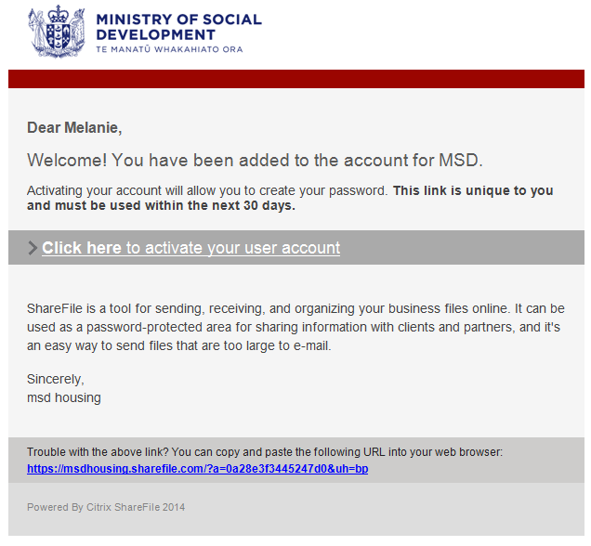
By clicking on this link you will be taken to the ShareFile ‘Change Password’ screen.
Enter your password as directed and save. Once you have completed this, you will be able to access ShareFile using your new password.
Passwords must be at least eight characters long and contain at least on character from three of the following character sets:
- Lower case letters (a to z)
- Upper case letters (A to Z)
- Numbers (0 to 9)
- Special Characters e.g. (~, +, =, &, ^, #).

Process when lodging a vacancy
Step one
To enter ShareFile from your internet browser type in:
http//msdhousing.sharefile.com/
This will take you to the following log in screen. You should bookmark this page so that it is easily accessible when you need to upload documents.
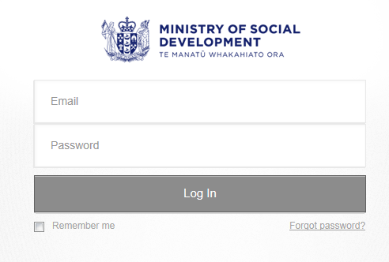

Enter your email address.
Enter your password.
Select the ‘Log In’ button.
The Administrator will have already created folders for you to use. To see these folders click on the ‘My Files and Folders’ button. You should see two folders:
- Contracts (your provider name)
- Centralised Unit Housing (CUH) (your provider name).

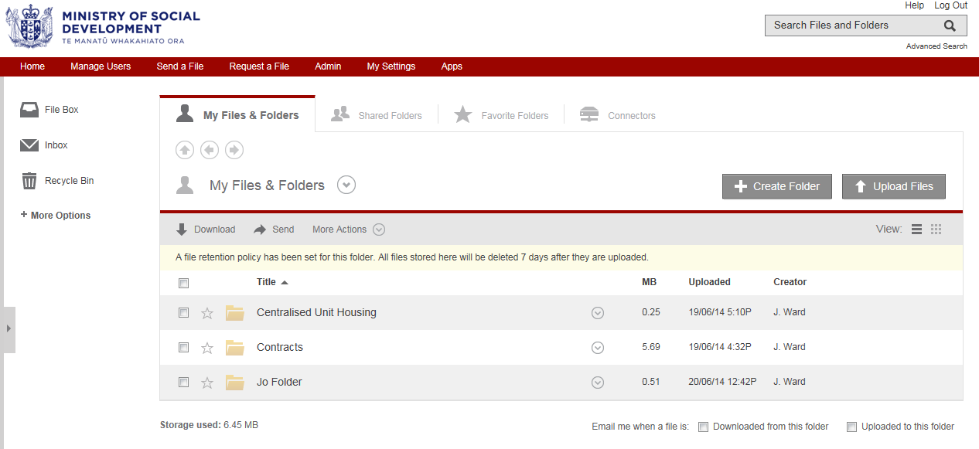

It will be in this screen that you will upload and download any documents that are part of the vacancy process. You will not need to use any other function within ShareFile.
Note: No other community housing provider will be able to see or use your folder.

Step two
Click on ‘Contracts’ folder.
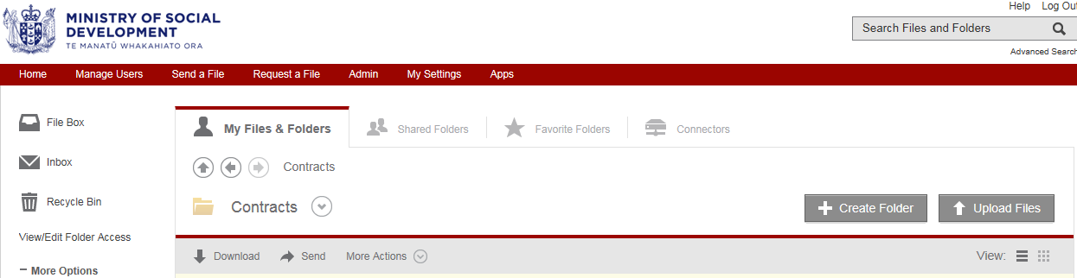

Step three
Click on ‘Upload Files’.

Step four
Click ‘Choose Files’. This will launch into your systems documents where you will need to select the Vacancy Notification form to upload.
Note: To download the Vacancy Notification form go to the Ministry’s housing website at www.housing.msd.govt.nz/documents/forms/provider-forms/vacancy-notification-sha117.docm.
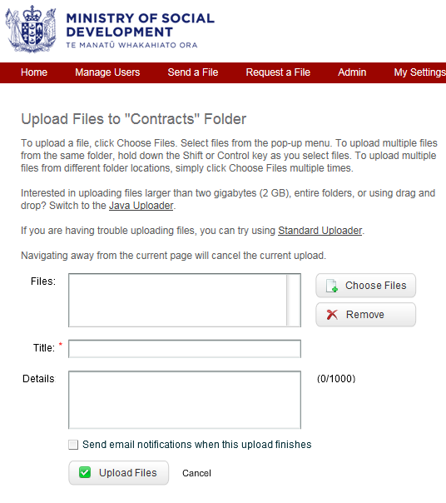
Once you have selected the Vacancy Notification form to upload, click on the ‘Upload Files’ button at the bottom of the screen.
Note: The Vacancy Notification form will be used until completed in full, throughout the process of vacancy offer to placement.

This next screen shows the email that the Contracts team will receive to advise they have a document to download. Once they click on the highlighted link they will be taken to their log in screen where they will log in and the document will open.
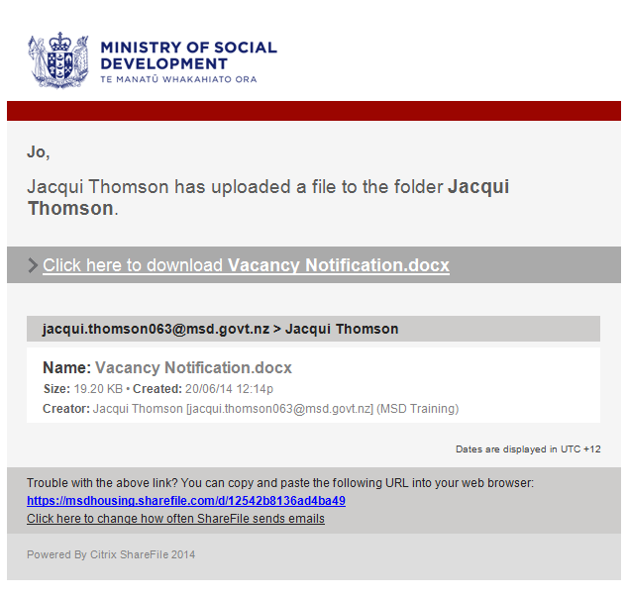
Step five
The General Manager Advisor (Contracts) will review the market rent.
Once they have approved the market rent they will complete the Vacancy Notification form and forward it back to you and at the same time send the Vacancy Notification form to the Centralised Unit Housing using ShareFile.
The Centralised Unit Housing will run a list of clients that match the vacancy profile; they will complete the relevant section of the Vacancy Notification form with a maximum of five clients that best match the criteria that you have requested.
The Centralised Unit Housing will upload the Vacancy Notification form into ShareFile for you to access. This process will take no longer than 48 hours. An email will be sent to you to advise that there is a form to download. The link in this email will take you to the Log In page (see step one). Once you have logged in, ShareFile will take you directly to the download page.
Click on the ‘Download’ button, which will open the document. Once the document is open you will need to save this to your own system.
Note: ShareFile will only keep the document in the folder for a maximum of seven days. After this time it will be deleted from ShareFile, so it is important that you save it to your own system.

Step six
If when provided the shortlist, it is indicated on the Vacancy Notification form that you need to contact the Centralised Unit Housing then you must do so. The client listed may require a different process, which Centralised Unit Housing will discuss with you.
If none of the shortlisted clients are suitable for your property, you will need to advise us by completing the ‘Property Offer Outcome’ section of the Vacancy Notification form with the reason why. You will then upload this form to the ‘Centralised Unit Housing’ folder and then to the ‘Contracts’ folder. This will ensure that for any unsuitable referrals, the clients are placed back on the housing waitlist. The General Manager Advisor (Contracts) can also keep a record of why the referrals provided are unsuitable.
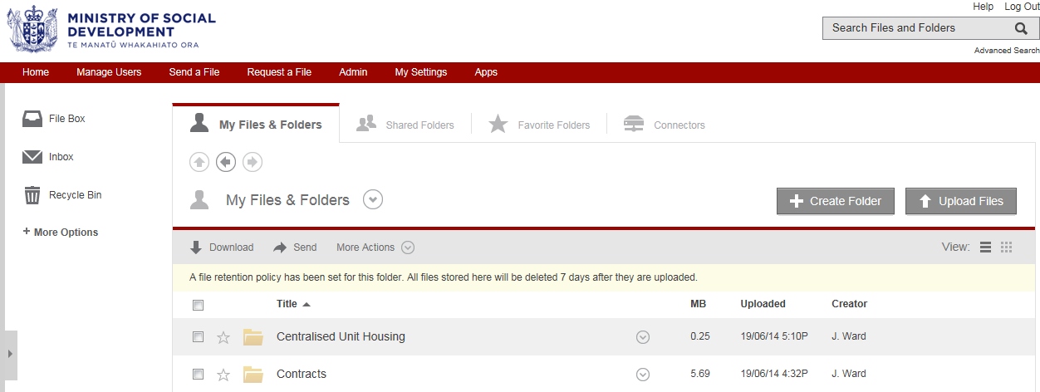

Step seven
If you select a client from the shortlist provided, you will then contact that client to arrange an interview and a viewing of the property.
You may decide to offer the property to the client. If you do, you will need to complete the Vacancy Notification form and upload this to the ‘Centralised Unit Housing’ folder in ShareFile.
If a client needs assistance with rent and bond you will need to advise the Centralised Unit Housing. This can be completed at the same time as the the Vacancy Notification form.
The Centralised Unit Housing will complete the Outcome of Application for Rent and Bond Payment and Redirection of Benefit form to advise you whether the rent, bond and redirection is approved or declined and the amount or income-related rent (IRR) and the IRR start date. This will be uploaded back to you through ShareFile.
- The Outcome of Application for Rent and Bond Payment and Redirection of Benefit form is available on the Ministry’s housing website at www.housing.msd.govt.nz/documents/forms/provider-forms/sha114-outcome-application-rent-bond-redirection.docm.
If we are unable to pay for rent and bond, you will need to discuss this with the client to confirm how they will meet these costs. If a rent redirection request is unable to be approved, you will also need to arrange rent payments directly with the client.
The Centralised Unit Housing will also send the form through to General Manager Advisor (Contracts) to inform them of what date the IRR should be activated.

